Paper Enzyme Activity

Background: Enzymes are proteins that help chemical reactions occur faster by lowering the energy that is needed for the reaction to occur. The enzymes react with a substrate to form an enzyme-substrate complex. Once this complex is formed the enzyme will break the bonds in the substrate and a product will be formed. The enzyme is then able to react with more of the substrates. The enzyme is shaped so that it will only react with a specific substrate. The substrate must fit into the enzyme for the reaction to occur.

Purpose: Your job will be to cut out, manipulate, glue and explain the reactions that are occurring with the pieces provided.

Procedure:
- Cut out all enzymes, products, and substrates.
- Organize the cutouts so that all the pieces demonstrate the equation below.
Enzyme + substrate enzyme-substrate complex enzyme + product 1 + product 2
- Glue the cutouts in the appropriate places.
- Label the cutouts.
  - Enzyme= Lactase
  - Substrate= Lactose
  - Products= glucose and galactose
- With the above terms explain the reaction and what happened.
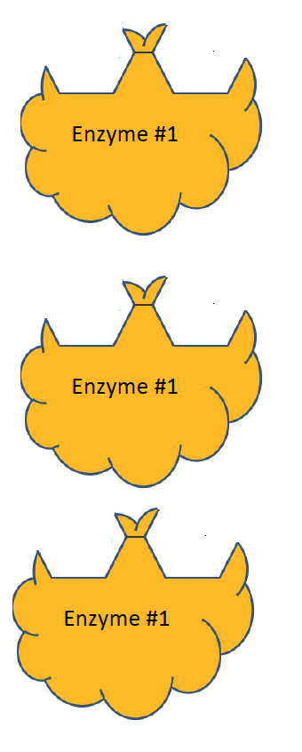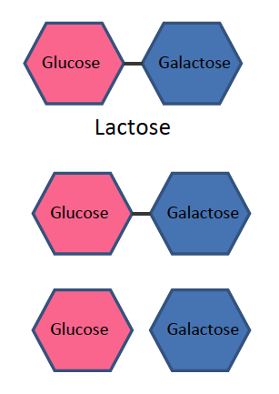

Enzyme | + | Substrate |  | Enzyme-Substrate Complex |  | Enzyme | + | Product 1 | + | Product 2

