Looking into Lactase
Topic(s): Chemical reactions, enzymes, macromolecules, pH
Grade level(s): 5th – 8th grades
Time: 45-80 minutes
Maine Science and Engineering Standards: 5-PS1-4, MS-PS1-2

ACTIVITY OVERVIEW
In this activity, students explore reactions between enzymes and disaccharide sugars while investigating lactose intolerance. Students explore the biological reasons behind the development of lactose intolerance and learn about and discuss the solutions that humans have developed in response, including milk substitutes and pharmaceuticals. Students will investigate the function of the lactase enzyme and they explore where in the human body the enzyme functions the best.

ALIGNMENT TO STANDARDS

5-PS1-4 Conduct an investigation to determine whether the mixing of two or more substances results in new substances.

MS-PS1-2 Analyze and interpret data on the properties of substances before and after the substances interact to determine if a chemical reaction has occurred.

LEARNING OUTCOMES

Upon completion of the Looking into Lactase lab students will be able to:

- Identify the causes behind symptoms resulting from lactose intolerance
- Identify the lactase enzyme’s specific substrate
- Differentiate between three different milk types based on their sugar content
- Explain how pH affects enzyme activity
- Infer how enzyme activity relates to human physiology

CAREER CONNECTIONS

Biological Technician

Biological technicians help biological and medical scientists conduct laboratory tests and experiments.

Work Environment: They typically work in laboratories, full-time. Examples of employers of biological technicians are the National Park Service, all branches of the military, medical facilities, and universities.

Duties: Typical duties include setting up, maintaining, and cleaning laboratory instruments and equipment, such as microscopes, scales, pipets, and test tubes; gathering and preparing biological samples, such as blood, food, and bacteria cultures, for laboratory analysis; and conducting biological tests and experiments.

Agricultural and Food Science Technicians

Agricultural and food science technicians assist agricultural and food scientists by performing duties such as measuring and analyzing the quality of food and agricultural products.

Work Environment: They typically work in laboratories, processing plants, farms and ranches, and greenhouses. Agricultural and food science technicians can find jobs with universities, pet food manufacturers, state and federal government (USDA, FDA), as well as any company in the food and beverage industry.

Duties: Agricultural and food science technicians test and catalog the physical and chemical properties of food to help ensure good taste, texture, quality, and safety. They create reports, charts and presentations based on their results. Much of the job is spent inspecting food (human and animal) to ensure it meets regulatory standards for consumption.

Chemical Technicians

Chemical technologists and technicians are workers who provide technical support or services in chemical-related fields. They determine the physical and chemical properties of compounds using quantitative and qualitative analyses.

Work Environment: They typically work in laboratories or in manufacturing facilities.

Duties: Chemical technicians use special instruments and techniques to help chemists and chemical engineers research, develop, produce, and test chemical products and processes. They may work under direct supervision or may work independently, depending on their specific position and duties.

Pharmacist

A pharmacist is a medical professional who dispenses drugs to patients according to a prescription ordered by a physician or other clinician. Pharmacists have an in-depth knowledge of the chemistry of various drugs and how they react in humans, and also how drugs interact with each other.

Work Environment: Pharmacists work in pharmacies, including those in grocery and drug stores. They also work in hospitals and other healthcare facilities. Some pharmacists work for the government and the military. In most settings, they spend much of the workday on their feet.

Duties: Pharmacists dispense prescription medications to patients and offer expertise in the safe use of prescriptions. They also may conduct health and wellness screenings, provide immunizations, oversee the medications given to patients, and provide advice on healthy lifestyles.

Sources:
https://www.bls.gov/ooh/

https://www.explorehealthcareers.org

BACKGROUND INFORMATION

One of the main goals of this activity is to help elementary and middle school students understand what enzymes are and how they function. Though this topic can be advanced for younger groups, it can be a great way to discuss chemical reactions that occur in our bodies. For groups learning about chemistry, the chemistry of digestion can be an interesting topic. The human digestive system utilizes both chemical and mechanical functions to break down our food into usable components. A focus can be on how an enzyme can catalyze a reaction up to 10 billion times faster than the comparable, non-catalyzed reaction. In other words, a reaction that only occurs once every ten billion seconds (316 years) will occur once every second if catalyzed by an enzyme. Enzymes are not consumed in the reaction and can bind to an infinite number of substrates.

Enzymes play a huge role in the digestion of sugars (carbohydrates), proteins, and fats (lipids). In this activity, students will learn what sugar the enzyme lactase interacts with and how changes to the environment, like pH, can change the enzyme's ability to function.

If students are focused on understanding chemical reactions, this activity can be used to focus on whether new substances are created after the addition of an enzyme. Because enzymes are specific to a substrate, they will only interact with one molecule. In the activity, lactase will be added to three different milk samples, but will only interact with the lactose sugar in the cow’s milk. Students should observe an increased amount of glucose sugar from before to after the addition of enzyme with the cow’s milk sample but not their other two milk samples.

Key Terms
- Enzyme – a substance produced by a living organism that acts as a catalyst to bring about a specific biochemical reaction
- Catalyst – a substance that increases the rate of a chemical reaction without itself undergoing any permanent chemical change
- Specificity – the narrowness of the range of substances with which an antibody or other agent acts is effective
- Activation energy – the minimum quantity of energy that the reacting species must possess in order to undergo a specified reaction
- Substrate – the substance on which an enzyme acts
- Disaccharide – any of a class of sugar whose molecules contain two monosaccharide residues
- Monosaccharide – any of the class of sugars that cannot be broken down into a simpler sugar
- pH – a figure expressing the acidity or alkalinity of a solution on a logarithmic scale on which 7 is neutral, lower values are more acidic, and higher values are more alkaline
- Qualitative – relating to, measuring, or measured by the quality of something rather than its quantity
- Quantitative – relating to, measuring, or measured by the quantity of something rather than its quality
- Independent variable- a variable (often denoted on the x-axis of a graph) whose variation does not depend on that of another
- Dependent variable – a variable (often denoted on the y-axis of a graph) whose value depends on that of another
PRE-LABORATORY ENGAGEMENT

Paper Enzymes

Before the mobile lab visit, it is recommended that students conduct the Paper Enzyme activity. This will introduce students to enzymes and enzyme specificity to help them build explanations when they come to the lab.

ADDITIONAL RESOURCES
Enzymes: http://www.chem4kids.com/files/bio_enzymes.html
Lactase Deficiency/Lactose Intolerance: http://www.webmd.com/digestive-disorders/tc/lactose-intolerance-topic-overview

POST-LABORATORY ENGAGEMENT

Enzyme Kinetics

After the mobile lab visit, students can continue to learn about enzyme kinetics and how pH can affect enzymes other than lactase. Students can practice graphing the data and drawing conclusions from the provided data.

LABORATORY SET UP

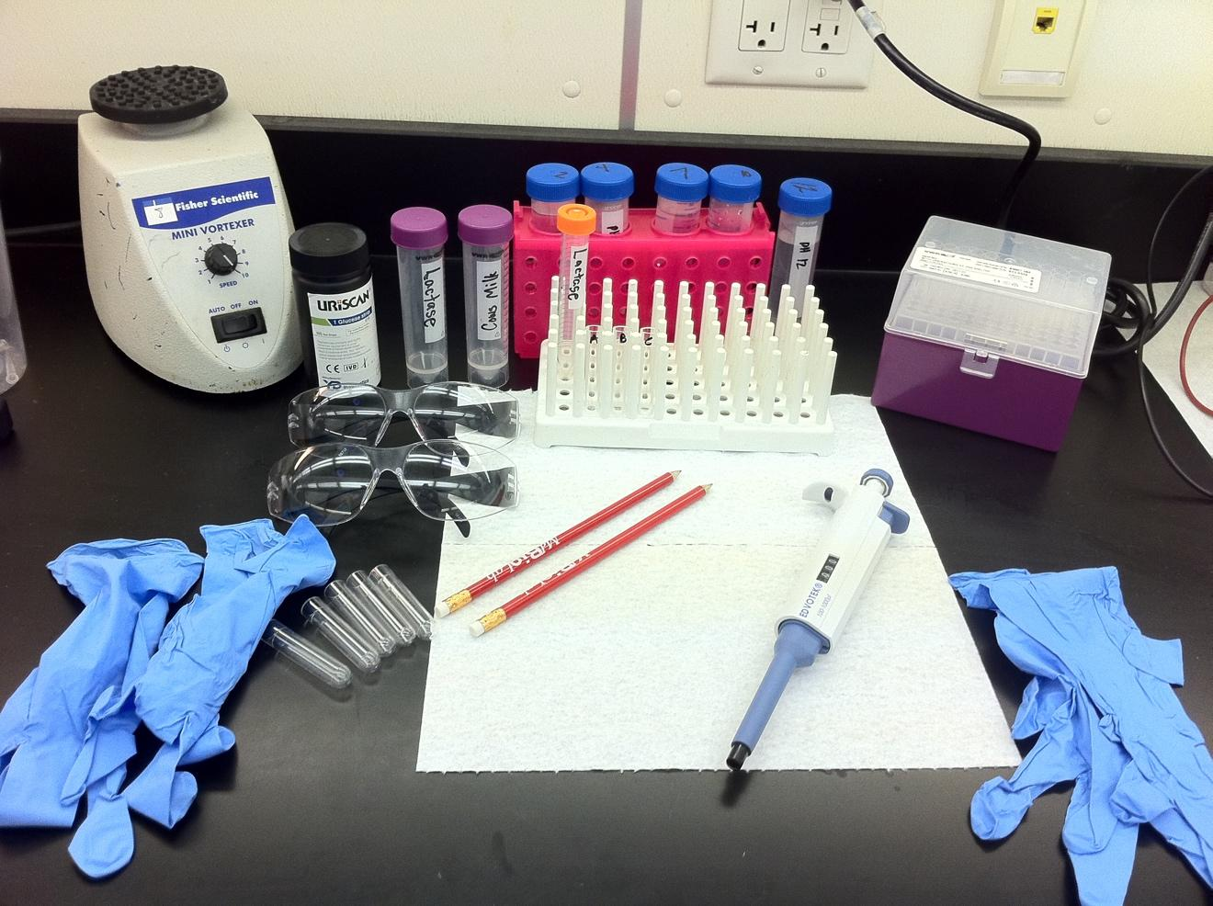

Materials
- Paper towel
- Pencils
- P1000
- P1000 tips
- Peg rack
- 3 test tubes of unidentified milk (cow, rice, soy) (A, B, C)
- 5 empty test tubes
- 15 mL conical of lactase
- 15 mL conical of cow’s milk
- Sharpie marker
- pH buffers in 50mL conicals and tube rack (2, 4, 7, 10, 12)
- Glucose test strips
- Vortex
- Tip waste container
- Goggles/glasses (optional)

REAGENT PREP

Milk Preparations
Purchase UHT milk that you can store at room temperature
1. Rice (Rice Dream)
2. Soy (Silk)
3. Whole milk (Horizon, unflavored whole milk)

Once open, store in refrigerator for up to one week, recommend to dispose of at end of school visit week

Unidentified milk samples aliquot
Prepare week of
Order is not important, though keep the order the same for each class
For example,
1. Sample A
a. 1 mL rice
2. Sample B
a. 1 mL whole milk
3. Sample C
a. 1 mL soy
Refrigerate for up to one week, recommend to dispose of at end of school visit week

Lactase Enzyme Stock Solution
Prepare as needed
1) Crush 12 lactaid pills into a fine powder with a mortar and pestle
a. If using powder instead of pills, aim for about 100,000 FCC units of lactase per liter.
b. It is suggested to test the solution with a cow milk sample before aliquoting for students.
2) Add to 1 L labeled Nalgene container
3) Fill to 1000 mL with dH₂O
Store at room temperature indefinitely

Lactase Enzyme Aliquot
Prepare as needed
1. Shake stock solution before aliquoting
2. Aliquot 15 mL into 15 mL conicals
Store at room temperature indefinitely

Cow Milk Aliquot
Prepare as needed
1. Aliquot 15mL of cow milk into 15 or 50mL conicals.
Refrigerate for up to one week, recommend to dispose of at end of school visit week

LESSON PLAN

Introduction (5-10 min)
- Welcome students to the lab and direct them where to grab gloves and where to sit.
- Explain to students that they will be acting as laboratory technicians at a biopharmaceutical company working to create a treatment for lactose intolerance.
- Ask students if they have heard of lactose intolerance before? If not, what do those words make them think of?
  - Students might know of some of the symptoms (gassy, upset stomach, diarrhea)
  - Students might piece together that intolerance means that you can’t deal with that substance.
- Ask students what foods have lactose in them?
  - Dairy products (milk, cheese, yogurt, ice cream, etc)
- Explain that lactose intolerance occurs when a person can’t digest lactose sugar. This is what causes all of the uncomfortable symptoms.
- Explain that lactose is a complex sugar, meaning that it’s made of two smaller sugars. Reference the table on page 1 of the handout. Explain that lactose is made of two shapes a square and a triangle and those shapes represent smaller sugars. Ask students what sugar they think the square represents? What about the triangle?
  - If they look at the third column of the table, students should see that the square represents glucose and the triangle represents galactose.
- Explain that in nature, glucose and galactose like to stay bonded together, but if we were to wait thousands of years they may fall apart. Explain that an enzyme (which is normally made by the body) can help to speed up that reaction.
- With a paper model, demonstrate how an enzyme is looking for a substrate that fits perfectly into the opening. When the enzyme finds the perfect substrate, the enzyme breaks the sugar into two smaller shapes. Explain that in this reaction, the enzyme remains intact and can do the same action to more substrates.
- Explain that today, the students will be investigating whether the manufactured lactase enzyme works to break down lactose sugar and only lactose sugar. The drug will be tested on different milk types that contain different sugars. If the enzyme acts interacts (breaks down) more than the intended lactose, it may not be approved for use by the FDA. To avoid bias, the activity will be a blind test, labeled A, B, or C. The main goal will be to identify which milk sample is which and to determine if the lactase enzyme only breaks down lactose.
Part 1: Identifying the Milk Type (20 minutes)
- Direct students to look at the 3 labeled tubes in their tube rack. Explain that these contain our 3 milk samples (cow’s, rice, and soy).
- Explain that our investigation will begin with a qualitative analysis. Ask students what qualitative means or what it makes them think of?
  - The quality of the substance. Includes color, smell, viscosity, etc.
- Direct students to write their qualitative observations for each milk in Table 2.
- Review observations as a class and ask for students to predict which milk is which.
- Direct students to look at the Uriscan stips and to take out 3. Explain that these test strips can measure the amount of glucose in a liquid. Direct students to label the strips A, B, and C (one for each test tube).
- Explain to students how to use the glucose test strip. Dip the blue end of the strip into the milk and immediately take out and set on the paper towel. Count to 10 then compare the color of the strip to the bottle to get the relative amount of glucose. Direct students to write this information as well as the observed color in Table 3.
- Review the collected data as a class. Ask students which sample indicated the presence of glucose?
  - There is only one that tests positive (this varies depending on how it’s aliquoted).
- Ask students to identify what type of milk must be in that test tube? Refer back to table 1 if needed.
  - This must be the rice milk as it’s the only milk that has glucose in it without needing to be broken down.
- Explain to students that we will now use the lactase enzyme to identify the soy and cow’s milks.
- Demonstrate how to invert the lactase sample for even distribution of the enzyme and review micropipetting technique.
- After students add lactase to all samples and vortex their samples to mix, direct students to test their samples with 3 new glucose strips and to record their observations in Table 4.
- Review the collected data as a class. Ask students in which tube then enzyme was actively cutting? Refer to the differences between Table 3 and 4 as necessary.
  - The enzyme only worked in one test tube (varies depending on aliquoting).
- Ask students, if the enzyme only changed on sample, what kind of milk must be in there?
  - Cow’s milk
Part 2: Determining the Effect of pH on Lactase Activity
- Explain that now that we know that the enzyme works specifically for lactose, the next test will help us to ensure that the enzyme will function in the right part of the digestive system.
- Ask students what parts of the digestive system they know?
  - Mouth, esophagus, stomach, intestines
- Explain that because each part of the digestive system has a different function, they operate at a different pH. Ask students if they’ve heard of pH before? If not, have they heard of acids and bases?
  - pH is a measure of how basic or acidic a substance is. The pH is a scale from 1-14. Substances below 7 are acidic and substances above 7 are basic. Substances at 7 are neutral.
- Explain to students that we want to see what pH is best for the lactase enzyme.
- Direct students to the pH solutions provided at their station. Remind them that even though they are all clear, colorless liquids, they are different substances and should use a new tip when pipetting.
- Guide students through the procedure to add their pH buffer, lactase enzyme, and cow’s milk to each tube.
  - If short on time, have each table test only 1 pH and collect class data to fill in pH’s not tested by them.
- Direct students to test the samples with the glucose strips.
- Review the collected data as a class. Ask students, which tube had the most activity? The most glucose produced?
  - pH 4
- Explain that scientist often display their information in graph to help people to see trends in the data.
- Guide students through the labeling of the x and y axis and graphing their collected data.
  - Explain that the line graph helps students to see how the activity increases as you go from pH 2 to 4 and decreases after pH 4.
- Explain that the small intestine normally produces the lactase enzyme and that the small intestine has a pH of 4. Will their lactase pill work where it’s supposed to?
  - Yes!
Closing (5 minutes)
- Congratulate students on their successful first day as laboratory technicians. Remind students that many companies in Maine need jobs like these to do their work.
- Explain more about 1-2 biotech companies in the area.

