Micropipette Challenge
Topic(s): Laboratory tools, Laboratory skills, Metric system, Following a protocol.
Grade level(s): 6th – 8th grades
Time: 45 minutes
Maine Standards: MS-PS4-2

ACTIVITY OVERVIEW
The Micropipette Challenge is a perfect introductory activity, allowing students to gain
experience with the tools and techniques, like the micropipette, that are used in many scientific
labs. In this lab, students work with small amounts of liquid to create a visible spectrum.
Students will also learn how to carefully read and follow a scientific protocol and gain
experience working with units in the metric system.

ALIGNMENT TO STANDARDS

MS-PS4-2 Develop and use a model to describe that waves are reflected, absorbed, or transmitted through various materials.

LEARNING OUTCOMES

Upon completion of the Micropipette Challenge, students will be able to:

- Understand how subtractive color mixing works
- Understand how to properly use a micropipette
- Read and follow a laboratory protocol
- Understand unit conversion
- Convert between microliters, milliliters, and liters

CAREER CONNECTIONS

Environmental Engineering Technician _____

Apply theory and principles of environmental engineering to modify, test, and operate equipment and devices used in the prevention, control, and remediation of environmental problems, including waste treatment and site remediation, under the direction of engineering staff or scientist. May assist in the development of environmental remediation devices.

Geneticists _____________________________

Research and study the inheritance of traits at the molecular, organism or population level. May evaluate or treat patients with genetic disorders.

Microbiologist

Investigate the growth, structure, development, and other characteristics of microscopic organisms, such as bacteria, algae, or fungi. Includes medical microbiologists who study the relationship between organisms and disease or the effects of antibiotics on microorganisms.

Chemist

Conduct qualitative and quantitative chemical analyses or experiments in laboratories for quality or process control or to develop new products or knowledge.

Sources:
http://www.worky.com/workypedia/careers-that-use-micropipettes/21/1974
BACKGROUND INFORMATION

The goal of this activity is to introduce students to important laboratory tools, be able to read and follow a basic lab protocol and understand the metric system. Understanding how to use laboratory tools such as the micropipette is important for students. It allows them to practice a skill that can come in handy should they choose a career that utilizes this too. They will already have a basic understanding of what the tool is, what the tool is used for, and how to properly set and measure out very small amounts of liquid using the tool.

This lab is also a great introductory lab to help students gain the knowledge and skills needed to learn how to read and follow a basic lab protocol. Learning to read scientific protocols and being able to follow them is important not only throughout their journey throughout high school lab class but can also spark an interest in a future career that puts them on the pathway for a STEM career. This knowledge can be invaluable as a student in college or beginning a introductory career inside a lab. Even if the student is not interested in a STEM career, this skill can be beneficial in helping the students understand how to read and follow through other technical writings throughout whatever path they choose.

Lastly, through this activity, we hope to help students understand the importance of the metric system in the scientific community. The United States is one of a few countries that still does not use the metric system for our known system of measurements. However, inside the lab quite often students will be utilizing the metric system, so having an understanding of it and the units involved with this system is important. The students will also learn how to convert from microliters to milliliters, another skill that can be invaluable to students in their future schooling or career pathways.

Key Terms
- Electromagnetic Spectrum: Electromagnetic waves exist with an enormous range of
frequencies. This continuous range of frequencies is known as the electromagnetic spectrum.
  - The longer wavelength, lower frequency regions are located on the far left of the
spectrum and the shorter wavelength, higher frequency regions are on the far right.
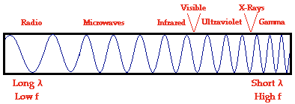
- Visible Spectrum: Although electromagnetic waves exist in a vast range of wavelengths, our eyes are sensitive to only a very narrow band. This narrow band of wavelengths is the means by which humans see called the visible light spectrum.
  - Dispersion of visible light produces the colors red, orange, yellow, green, blue, and violet. It is because of this that visible light is sometimes referred to as ROY G BIV.
  - The red wavelengths of light are the longer wavelengths and the violet wavelengths of light are the shorter wavelengths.
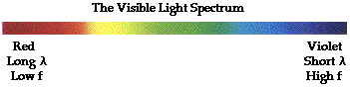
- Metric System: A type of decimal measuring system

Table A.1: The units of the metric system and their symbols
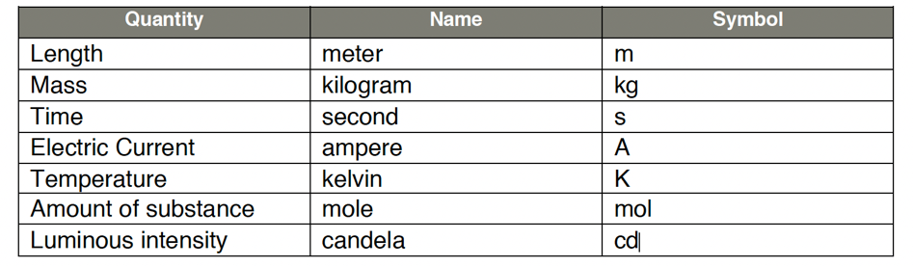

Table A.2: Derived units in the metric system and their symbols
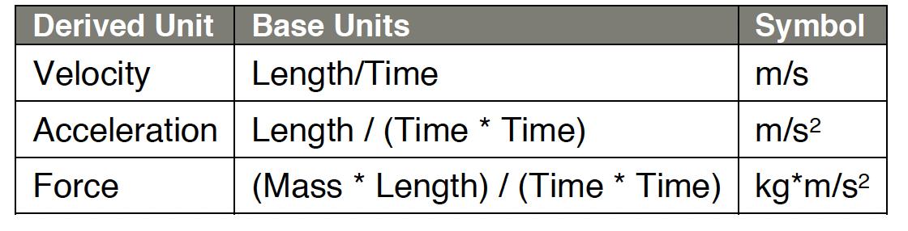
- Conversion Factor: A multiplier for converting one set of units into another equivalent type of unit.
  - Example: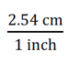
  - How to use a conversion factor:
    - Write the conversion as a fraction that equals 1 (include units; see example above)
    - Multiply the desired unit by the conversion factor; ensure that the unit being converted is in the denominator of the conversion factor, and that the desired unit is in the numerator of the conversion factor.
    - Calculate the answer by multiplying the number being converted by the conversion factor.

For more information, follow these links:

- Micropipettes: https://bit.ly/2NAaPti
- Electromagnetic Spectrum: https://www.physicsclassroom.com/class/light/Lesson-2/The-Electromagnetic-and-Visible-Spectra
- Metric System: https://www.mathsisfun.com/measure/metric-system.html
- Unit Conversions: https://www.mathsisfun.com/measure/unit-conversion-method.html
PRE-LABORATORY ENGAGEMENT

Color Reflection and Absorption

Before the mobile lab visit, it is recommended that students conduct the Color Reflection and Absorption activity. In this activity, students will determine the colors that make up white light and how the colors we see are the colors reflected from that surface.

POST-LABORATORY ENGAGEMENT

Colored Shadows

After the mobile lab visit, students can continue to learn about light and light waves. Using the Science Buddies: Colored Shadows activity students will learn how additive color mixing differs from the subtractive color mixing seen in the pre-lab and lab activity.

The Exploratorium video can also be used to help set up or demonstrate this experience.

LABORATORY SET UP

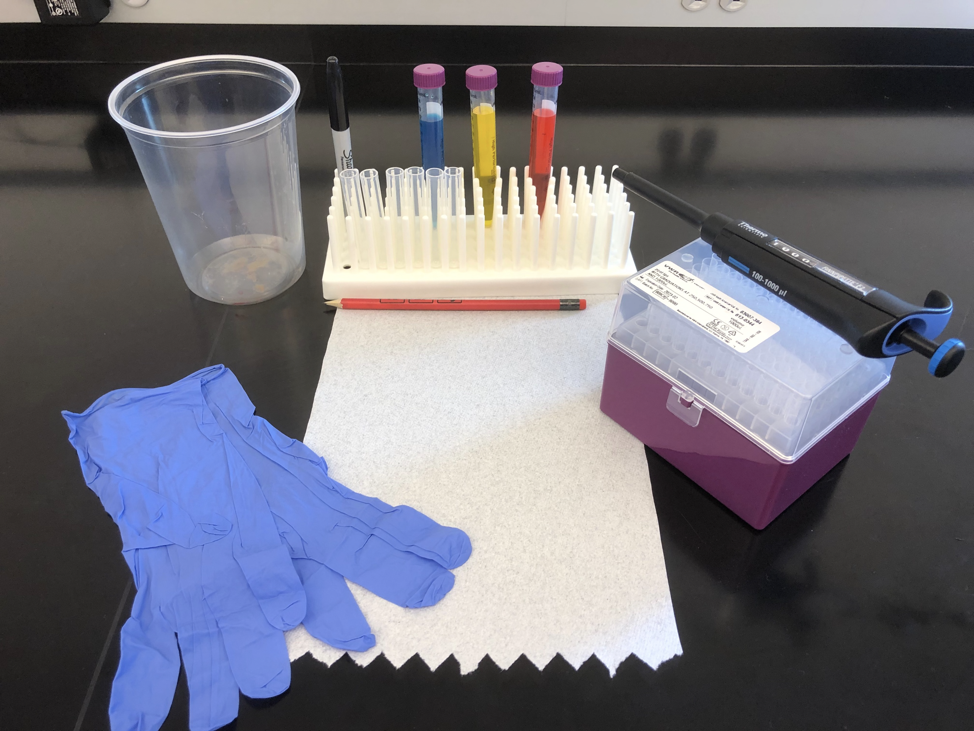
1
2
3
4
5
6
7
8
9

1
0

Materials
- Paper towel
- Plastic trash container
- Marker
- Six 5 mL test tubes
- Three 15 mL test tubes (red, yellow, blue)
- Peg rack
- P1000 Micropipette
- Micropipette tips
- Gloves
- Pencil

REAGENT PREP

Prepare Colored Water

- Mix 4 drops of red food coloring with dh20 into a 50 mL tube (x4)
- Mix 2 drops of yellow food coloring with dh20 into a 50 mL tube (x4)
- Mix 3 drops of blue food coloring with dh20 into a 50 mL tube (x4)
- Divide colors into 15 mL test tubes

LESSON PLAN

Introduction (5 min)
- Welcome students to the lab and direct them where to sit.
- Explain to students:
  - Gee, Roy, and Biv are having problems with their science lab. Their teacher has asked them to create a spectrum–but none of them have a clue as to how to make one.
  - A spectrum is a display of light or other forms of radiation separated by properties—most often people think of the electromagnetic spectrum which is the entire range of light. The visible spectrum, the part of the spectrum that we can see with our eyes, is only a small part of the entire electromagnetic spectrum.
  - Today you will be helping Gee, Roy, and Biv by constructing your own spectrum
Part 1: Using a Micropipette (15 minutes)
- However, to do that the first thing we need to do is learn how to use our equipment.
- Hold up a micropipette and ask does anyone knows what this is
  - Students will have varying answers.
  - Explain to the students that a micropipette is an accurate and precise instrument used to measure very small amounts of liquid–frequently millionths of a liter. One-millionth of a liter is equal to one microliter, abbreviated 1μL
- Now that you know what a micropipette is, let’s talk about how to use it.
  - There are a few parts of the micropipette that we want to know.
    - The number on the side of the micropipette is the amount of liquid this pipette can hold. This pipette can hold 100 -1000 microliters. Microliters are a very small unit of measurement. Think about a 2-liter bottle of soda (show the 2-liter bottle of soda) it would take 2 million microliters to fill this bottle.
    - The clear window on the side with the rotating numbers tells us how many microliters our micropipette is picking up at the moment.
    - The micropipette has a plunger that helps us to pick up liquid, this plunger can turn to change the amount of liquid you will pick up.
      - To change the amount of liquid we pick up you will rotate the plunger clockwise or counterclockwise, depending on if you want to increase or decrease the number in the window.
        - Remember our micropipette works in a range of 100-1000 microliters, so we want to make sure we do not go below 100 or above 1000 when changing the number in the window. If you do you can mess up the calibration of the micropipette and it will not work correctly.
      - To pick up the liquid there are a few other things the plunger can do. For example, when pressing down on the plunger you will notice there are two stops on a micropipette, 1st stop and 2nd stop. When you press the plunger down on the micropipette you will feel it come to a natural stop and notice there is still a small amount of room that you can still press the plunger down. This is our 1st stop. We also have a 2nd stop, when you press the plunger completely down and there is no more room between the plunger and the micropipette this is our 2nd stop.
      - When we go to pick up a liquid you will press your pipette down to the first stop, place the tip into the liquid, and then release, this will pick up the exact volume. To eject the liquid from the pipette you will place your pipette over your tube and press down to the second stop to give the pipette extra air to get all of your liquid or sample out of the tip.
    - Pipette tips are also a very important part of the micropipette, you always want to make sure that you have a tip on your micropipette before putting it into the liquid you are using. If not, you could risk getting the liquid into the mechanical parts of the micropipette and breaking it.
    - There is an eject button located here on the micropipette which allows you to change your tip. Just make sure you are over the waste bin before pushing it.
      - Pipettes are used for many different science experiments and are commonly found in forensics labs. When using a pipette, we do not want to contaminate our samples so we will need to change our pipette tip after you pick up each sample.
    - Now it’s your turn to try! Grab a tip and set your micropipette to pick up 600 microliters of blue liquid. Great!
    - Now, dispense the liquid back into the 15ml conical with the blue liquid. Awesome Job!
    - Awesome now that we know how to use a micropipette, we are good to go for this challenge!
Part 2: Completing the Spectrum (the lab) (20 minutes)
- Walk students through the procedure.
- Reminders to give students:
  - Many of these volumes are larger than 1,000 microliters, but our micropipette has a maximum value of 1,000. Ask students how we can measure 1,900 microliters with a 1,000 microliter pipette.
    - We can divide the 1,900 into smaller increments. For example, we could do 1,000 and 900 or we could do 950 two times.
  - Remind students that as they add liquid to the tubes, they should record those volumes in the table. If we add liquid to the numbered tube (not the stock tubes of red, blue, yellow) we should have a plus sign (+) in front of the number. If we remove liquid from the numbered tube we should have a minus sign (-) in front of the number.
- When students reach step 8, have them predict what they think will happen when the yellow liquid is added to the red.
  - It should combine to create orange.
    - If students have completed the pre-lab, remind them that the color we see is the colors reflected while all other colors of white light are absorbed.
    - Students may be confused because we explained that red paper reflected red light and absorbed all others. With this logic they might think that adding red and yellow would cause them both to cancel out (the yellow cancels out the red and the red cancels out the yellow).
      - No dyes or pigments are pure colors; they reflect light over a narrow wavelength band (reflecting some but not all colors). Yellow dye reflects yellow light, but also reflects small amounts of orange and green light while absorbing red and blue light. Red paint absorbs blue and yellow light, but reflects a bit of orange. When yellow and red paints are mixed, the yellow paint absorbs the red light and the red paint absorbs the yellow light, but they both reflect orange. So the mixture appears orange. When two paints mix, the color produced is the color that both paints reflect.
- Continue to have students predict the colors as two colors are mixed together.
- When groups have finished the procedure, have them add the values in each row to get the total volume in each tube and its color.
- Guide students on how to convert from microliters to milliliters for all values.
- Have students look at their tubes and see if they all have the same amount of liquid (as we calculated with our addition and subtraction).
  - Common errors in micropipette usage will result in the transfer of different volumes than the one intended. For example, if there are air bubbles in tip of the pipette, a smaller volume than intended is transferred. When students press to second stop and release while in the liquid, they will transfer a larger volume than the one intended.
  - Explain that with more practice, students can get more accurate results.
Closing (5 minutes)
- Congratulate students on completing a visible spectrum. Talk about how the levels should be completely level or even. Remind students that if they liked this there are many jobs that require the use of micropipettes.
- Explain more about 1-2 lab jobs that require the use of micropipettes.

