Parasite Predicament

Topic(s): Antibody, antigens, immune system,
Grade level(s): 9th – 12th grades
Time: 60-80 minutes
Maine Science and Engineering Standards: MS-LS1-3, HS-LS1-2

ACTIVITY OVERVIEW
In this activity, students explore the relationship between antigens and antibodies and how those interactions are used in diagnostic tests, specifically enzyme-linked immunosorbent assays (ELISA). Students will learn how antibody specificity allows for the targeting of one specific antigen (molecule from a pathogen or foreign substance). In this experience, students will use an ELISA to test a patient sample to determine whether or not the patient has malaria.

ALIGNMENT TO STANDARDS

MS-LS1-3 Use argument supported by evidence for how the body is a system of interacting sub-systems composed of groups of cells.

HS-LS1-1 Develop and use a model to illustrate the hierarchical organization of interacting systems that provide specific functions within multicellular organisms.

LEARNING OUTCOMES

Upon completion of the Parasite Predicament lab, students will be able to:

- Identify the receptor site of an antibody
- Understand that antibodies and antigens bind in a lock and key fashion
- Understand how antibodies can be used to fight infection
- Understand how antibodies can be used to detect the presence of a pathogen
- Conduct an ELISA

CAREER CONNECTIONS

Biological Technician

Biological technicians help biological and medical scientists conduct laboratory tests and experiments.

Work Environment: They typically work in laboratories, full-time. Examples of employers of biological technicians are the National Park Service, all branches of the military, medical facilities, and universities.

Duties: Typical duties include setting up, maintaining, and cleaning laboratory instruments and equipment, such as microscopes, scales, pipets, and test tubes; gathering and preparing biological samples, such as blood, food, and bacteria cultures, for laboratory analysis; and conducting biological tests and experiments.

Medical Scientists

Medical scientists conduct research aimed at improving overall human health

Work Environment: Medical scientists typically work in offices and laboratories. Most work full time, and some work more than 40 hours per week.

Duties: Medical scientists design an conduct studies to investigate human diseases and methods to prevent and treat diseases, create and test medical devices, prepare and analyze data from medical samples and investigate causes and treatment of toxicity, pathogens, or chronic disesases.

Epidemiologists

Epidemiologists are public health workers who investigate patterns and causes of disease and injury. They seek to reduce the risk and occurrence of negative health outcomes through research, community education and health policy.

Work Environment: Epidemiologists work in offices and laboratories, usually at health departments for state and local governments, in hospitals, and at colleges and universities.

Duties: Epidemiologists collect and analyze information to find the causes of diseases or other health problems, plan and direct studes of public health problems to find ways to prevent them or to treat them if they arise.

Microbiologists

Microbiologists study microorganisms such as bacteria, viruses, algae, fungi, and some types of parasites. They try to understand how these organisms live, grow, and interact with their environments.
Work Environment: Microbiologists typically work in laboratories, offices, and industrial settings where they conduct experiments and analyze the results. Microbiologists who work with dangerous organisms must follow strict safety procedures to avoid contamination. Some microbiologists may conduct onsite visits or collect samples from the environment or worksites, and, as a result, may travel occasionally and spend some time outside.

Duties: Microbiologists perform laboratory experiments that are used in the diagnosis and treatment of illnesses, identify and classify microorganisms found in specimens collected from humans, plants, animals, or the environment.

Sources:
https://www.bls.gov/ooh/

https://www.explorehealthcareers.org

BACKGROUND INFORMATION

In this activity, students will first focus on antibodies and antigens and then will transition to conduct an ELISA and see how the relationship between the two molecules can be used in diagnostics.

An antibody is a y-shaped protein component of the immune system that circulates in the blood, recognizes foreign substances (pathogens) like bacteria and viruses, and neutralizes them. On the exterior of these pathogens are proteins that are foreign to the human body called antigens. Each pathogen can have hundreds of antigens. Antibodies are produced to detect one specific antigen and their receptor site is constructed in a way that it can only bind to that one antigen. Using this binding mechanism, an antibody can tag a microbe or an infected cell for attack by other parts of the immune system, or can neutralize it directly (for example, by blocking a part of a virus that is essential for its invasion).

Enzyme-linked immunosorbent assays (ELISAs) use this relationship to detect the presence of an antigen. In an indirect sandwich ELISA, there are antibodies bound to the well’s surface that act as capture antibodies. If patient serum is added and the antigen is present, the antigen will bind to the capture antibodies and will remain in the well. In this activity, a primary antibody is added that binds to the antigen. Then a secondary antibody with an enzyme attached is added and it binds to the primary antibody, completing our sandwich. Then an enzyme substrate is added which interacts with the enzyme from the secondary antibody and produces a blue color solution. In this ELISA, the presence of dye indicates the presence of the antigen.

Additional Resources
Types of ELISA
What is an antibody?
Immune sytem review

PRE-LABORATORY ENGAGEMENT

Uses for Monoclonal Antibodies

Before the mobile lab visit, students can complete the Uses for Monoclonal Antibodies activity to get an introduction to antibodies and their specific binding patterns. In this activity, students will learn how antibodies bind to a specific substrate, an antigen. They will learn how this interaction can be used in a diagnostic setting as they model how a pregnancy test detects the presence of the hCG hormone.

POST-LABORATORY ENGAGEMENT

Build a Monoclonal Antibody

After the mobile lab visit, students can continue to learn about antibodies and their uses in clinical settings. In this activity, students will be presented with a scenario and will have to decide which antibody to use and if the antibody should be marked with fluorescent dyes or drugs to accomplish the goal.

LABORATORY SET UP

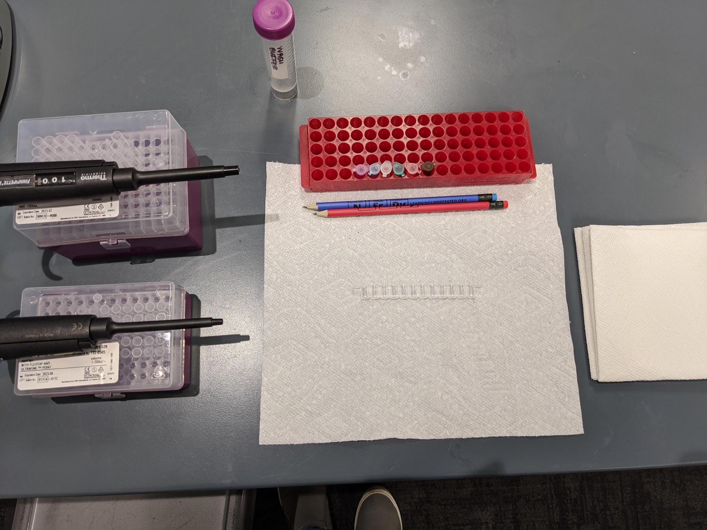

Materials
- Paper towel
- 2 Pencils
- P1000
- P1000 tips
- P50
- P200 tips
- Tube rack
- 0.6 mL microcentrifuge tubes- samples (+, -, P)
- 0.6 mL microcentrifuge tubes- antibodies (PA, SA, Indicator)
- 50 mL conical of wash buffer
- Sharpie marker (not pictured)
- ELISA well strip
- Quartered paper towels (approximately 10 per station)
- Tip waste container at center of table

REAGENT PREP
*all solutions are made from the Bio-Rad ELISA Immuno Explorer Kit*

1X PBS buffer
Prepare as needed
1. Add to 1 L Nalgene container
a. 90 mL dH₂O
b. 10 mL 10x PBS
2. Shake to mix
Uses:
· Rehydrating antigen, primary, and secondary antibodies to make 50X reagent stock solutions
· Diluting 50X antigen to make positive control and “infected” student samples
· Negative control and negative student samples
Store at room temperature indefinitely

Wash Buffer
Prepare as needed
1. Add to 1 L Nalgene container
a. 805 mL dH₂O
b. 90 mL 10X PBS
c. 4.5 mL 10% Tween 20
2. Shake to mix
Uses:
· Dilution of 50X antibody stocks
· Plate washing
Store at room temperature indefinitely

50X Antigen Solution
Prepare as needed
1. Add directly to antigen
a. 0.5 mL 1X PBS buffer
2. Vortex
Uses:
· Creates stock solution to be diluted for student samples
Dilute immediately to 1X Antigen

50X Primary Antibody Solution
Prepare as needed
1. Add directly to primary antibody bottle
a. 0.5 mL 1X PBS buffer
2. Vortex
Uses:
· Creates stock solution to be diluted for student samples
Dilute immediately to 1X Primary Antibody

50X Secondary Antibody Solution
Prepare as needed
1. Add directly to secondary antibody bottle
a. 0.5 mL 1X PBS buffer
2. Vortex
Uses:
· Creates stock solution to be diluted for student samples
Dilute immediately to 1X Secondary Antibody

1X Antigen Stock Solution
Prepare as need
1. Add to labeled 50 mL conical
a. 24.5 mL 1X PBS
b. 0.5 mL 50X antigen solution
2. Shake to mix
Store in refrigerator for several months

1X Primary Antibody Stock Solution
Prepare as need
1. Add to labeled 50 mL conical
a. 24.5 mL wash buffer
b. 0.5 mL 50X primary antibody solution
2. Shake to mix
Store in refrigerator for several months

1X Secondary Antibody Stock Solution
Prepare as needed
1. Add to labeled 50 mL conical
a. 24.5 mL wash buffer
b. 0.5 mL 50X secondary antibody solution
2. Shake to mix
Store in refrigerator for several months

Sample aliquots for class

Sample label |  | Tube color | Volume
+ | 1X Antigen | White | 200 μL
- | 1X PBS | White | 200 μL
P | Alternate antigen and 1X PBS | White | 200 μL
PA | 1X Primary antibody | Green | 500 μL
SA | 1X Secondary antibody | Pink | 500 μL
 | Enzyme substrate | Amber | 500 μL

Store in refrigerator for several months
LESSON PLAN

Introduction (10-15 min)
- Welcome students to the lab and direct them where to grab gloves and where to sit.
- Explain to students that they will be acting as laboratory technicians at a hospital.
- Remind students that the name of today’s activity is Parasite Predicament. Ask students what if means for something to be a parasite or be in a parasitic relationship.
  - There is one organism that benefits while the other is harmed
- Ask students if they know any parasites.
  - Students might mention, malaria, giardia, toxoplasma gondii, or tapeworms.
  - Tell them that today we will be focusing on malaria.
- Ask students how malaria is spread.
  - Commonly through mosquito bites.
  - Explain that the parasite live in the mosquito and are spread to humans through the mosquitos saliva when they bite us. Explain that the parasite then travels to the liver where it matures and reproduces. Eventually the parasite leaves the liver and targets red blood cells. As the malaria reproduces in the red blood cell, the red blood cell bursts as there isn’t enough space for everything, this then leads to more red blood cells getting infected.
  - Explain that this cycle causes fevers, headaches, shivering, joint pain, vomiting, yellowing of the skin (jaundice), retinal damage, and convulsions. A hallmark of malaria is the cyclical occurrence of suden coldness followed by shivering, fever and sweating every 36-48 hours.
- Ask students where in the world malaria is most prevalent. Ask students where the climate is warm and muggy, ideal for mosquitos.
  - Equatorial regions. This includes central American and norther parts of South America, central Africa and the Mediterranean, and Southeast and East Asia.
- Set the stage for today’s case study. A 36-year-old woman has been rushed to the hospital. Her symptoms are similar to those of the flu, but she has not responded to antiviral influenza medicine. The patient’s family history is recorded, as well as a recent travel record. The travel record from the last two years includes a camping trip in the northwestern United States, and a cruise around the Mediterranean.
- Explain to students that they will be conducting a diagnostic test to see if the patient has contracted malaria.
- Explain that the test we will be using is called ELISA which stands for enzyme-linked immunosorbent assay. This will use the antibody antigen relationship to help detect if the patient has malaria.
- Ask students if they have heard of antibodies before.
  - Some might have and might be familiar with the antibody testing that was done early in the COVID days.
- Explain to students that antibodies are a protein created by the immune system to detect foreign substances, called pathogens. Explain that the antibodies are a Y shaped protein and have two receptor sites that are specific to one antigen. Explain that an antigen is a protein or molecule found on the exterior of a pathogen.
- Using the diagram on the handout, label the top arrow as a receptor and the bottom arrow as antibody. Ask student which antigen will bind to this antibody.
  - The light blue one (bottom left) because it has the same shape as the receptor.
  - Remind students that antibodies and antigens fit together like a lock and a key
- Explain that our ELISA is a sandwich ELISA. To start the wells at the stations are already coated with an antibody that is specific to a malaria antigen. When we add the patient sample to the well, the antigen will bind and everything else will fall out.
  - Draw the steps as you go:

- Remind students that this is a sandwich ELISA. So if we have antibody on the bottom and antigen in the middle, what needs to go on top?
  - More antibody
- Explain that a Primary Antibody will be added that will only bind to malaria.
  - Draw this

- Then to detect the presence of this complex, we add a Secondary Antibody. The secondary antibody is specific to the primary antibody and has an enzyme attached to it.
  - Draw this

- Next to show that everything is there, the enzyme substrate is added. This will interact with the enzyme attached to the secondary antibody to produce a blue dye.
  - Draw this

ELISA (30-40 min)
- Direct students to look at the labeled tubes in their tube rack. Explain that the (+) contains a positive control. If its our positive control, what substance in in the liquid?
  - The malaria antigen
- Explain that the (-) contains our negative control which does not have any antigens. The (P) contains our patient sample.
- Explain that we will be conducting this assay in triplicate, meaning 3 trials for each sample. Have students fill in the table with the labels for each sample and the following well numbers:
  - Positive control, +, (1,2,3)
  - Negative control, (-), (5,6,7)
  - Patient sample, P, (9,10,11)
    - Explain that we will leave an empty well between samples to prevent cross-contamination.
- Have students label the well strip with their sharpie so it matches the image on the handout.
- Review microliters and micropipetting technique before continuing to step 2.
- Once students have reached step 5, there will be a 5 minute incubation period. Explain that this allows time for any present antigen to bind to the antibodies coating the well.
- As their samples incubate, explain the washing steps. Ensure students place their strip upside down and gently tap. They should not pick it up and put it down repeatedly as they might put it down in a slightly different location and it could contaminate the sample. Students can use their pencils to help tap the liquid out of their strip.
- After adding wash buffer, students can use the same paper towel, but in a new clean location to dump it out. After the second round of wash buffer has been emptied, the top paper towel can be disposed of.
  - Note: Subsequent paper towels in the stack will be wet, but any antigens or antibodies present will not be able to pass through the paper towel.
- After this, allow students to work through the procedure on their own and provide time checks to keep students paced for the class.
- Remind students that the final wash before adding the enzyme substrate will happen three times instead of the usual two.
- As students samples turn blue, explain that in our test any blue result indicates the presence of malaria. Explain that there are more sophisticated versions of this test that can use computer imaging to identify how much color is present, with a spectrophotometer, and this allows us to know how much antigen is present (is it early in the infection or later). These tests can also use fluorescent molecules instead of dyes as well.
  - Ask students to consider the last two questions on the handout. Why would we have tested the patient to Sickle Cell in addition to malaria given her symptoms?
    - It is known that sickle cell and malaria are evolutionarily tied together. Those with sickle cell have red blood cells that are hard and rigid (given their sickle shape) and do not allow malaria to get in as easily. In areas prevalent with malaria, there is a heterozygous advantage to sickle cell. They have one normal hemoglobin gene to have normal red blood cells and they have one that causes sickling. This allows them to avoid many symptoms of full sickle cell and still have a 50% chance that the malaria won’t get into their cells due to the sickling.
Closing (5 minutes)
- Congratulate students on their successful first day as laboratory technicians. Remind students that many companies in Maine need jobs like these to do their work.
- Explain more about 1-2 biotech companies in the area.

