Water Quality

Topic(s): Environmental science, chemistry, filtration
Grade level(s): 6th – 8th grades
Time: 45-60 minutes
Maine Science and Engineering Standards: MS-LS2-5

ACTIVITY OVERVIEW
In this activity, students explore water quality and some of its parameters. Students will discuss why water quality is important and the effects of poor water quality on human needs and ecosystem needs. Students will use parameters including pH and turbidity to determine the quality of the water at the start. Students will also design different filters to determine how different materials are capable of removing pollutants. Students will use visual observations as well as the water quality parameters to determine how well their filter worked.

ALIGNMENT TO STANDARDS

MS-LS2-5: Evaluate competing design solutions for maintaining biodiversity and ecosystem services.

LEARNING OUTCOMES

Upon completion of the Water Quality lab students will be able to:

- Define what water quality is
- Determine safe levels for pH and turbidity
- Evaluate filter designs to determine the best filter to improve water quality

CAREER CONNECTIONS
Hydrologists
Hydrologists study how water moves across and through the Earth’s crust.

Work Environment: Hydrologists work in offices and in the field. In offices, hydrologists spend much of their time using computers to analyze data and model their findings. In the field, hydrologists may have to wade into lakes and streams to collect samples or to read and inspect monitoring equipment.

Duties: Hydrologists study how water moves across and through the Earth’s crust. They study how rain, snow, and other forms of precipitation impact river flows or groundwater levels, and how surface water and groundwater evaporate back into the atmosphere or eventually reach the oceans. Hydrologists analyze how water influences the surrounding environment and how changes to the environment influence the quality and quantity of water. They use their expertise to solve problems concerning water quality and availability.

Environmental Scientists and Specialists
Environmental scientists and specialists use their knowledge of the natural sciences to protect the environment and human health.

Work Environment: Environmental scientists and specialists work in offices and laboratories. Some may spend time in the field gathering data and monitoring environmental conditions firsthand. Most environmental scientists and specialists work full time.

Duties: Environmental scientists and specialists use their knowledge of the natural sciences to protect the environment and human health. They may clean up polluted areas, advise policymakers, or work with industry to reduce waste. They determine data collection methods for projects, analyze samples to identify threats to the environment, and develop plans to prevent, control, or fix environmental problems.

Environmental Science and Protection Technicians
Environmental science and protection technicians monitor the environment and investigate sources of pollution and contamination, including those affecting public health.

Work Environment: Environmental science and protection technicians typically work in offices, laboratories, and the field. Most environmental science and protection technicians work full time, and some work more than 40 hours per week.

Duties: Environmental science and protection technicians monitor the environment and investigate sources of pollution and contamination, including those affecting public health. They typically set up and maintain equipment to monitor pollution levels, collect samples for laboratory analysis, and use equipment, such as microscopes, to evaluate and analyze samples for the presence of contaminants.

Sources:
https://www.bls.gov/ooh/

BACKGROUND INFORMATION

What is water quality?
Water quality is commonly defined by its biological, physical, chemical and aesthetic (appearance and smell) characteristics. A healthy environment is one in which the water quality supports a rich and varied community of organisms and does not harm public health. The water quality of a body of water influences the way in which communities use the water for activities such as drinking, swimming or commercial purposes. It is an important environmental, economic and social resource in our world.

What are some indicators of water quality?

Water quality can be evaluated by how many and how varied the biota (living organisms) is in a stream. There are many factors that are important to the biota that use the stream. The chemical factors that influence the biota are dissolved major ions, dissolved nutrients, dissolved organic matter, dissolved gases (oxygen, carbon dioxide) and trace metals. Variation in these factors is determined by the type and amount of rocks, weathering, precipitation type and amount, and proximity to the sea. Seasonality also has an influence on chemical factors. Areas of high rainfall and surface water runoff have more dilute stream water compared to areas that are arid and have greater evaporation. Biological influences of these factors are normally seen only during times of extreme change. For example, anthropogenic (human) inputs of pollution or wastes may change the stream water chemistry to a pH below 5.0, which would drastically affect the flora and fauna.

Filtration
Water filtration is a method of cleaning water by passing it through a filter (permeable substrate). Permeability is the measure of how easily a liquid can pass through a substance.
This activity explores the various filter media available. Once water is dirty or polluted, it can be very complicated to clean. Many steps may be necessary to filter dirty water! The rocks and sand formed by erosion perform a very important function: they help to clean our water supply. Sand and gravel make good water filters because they form permeable layers. When the sand particles are next to one another, there are tiny spaces between them. Water can pass slowly through these tiny spaces and some of the dirt particles get trapped. The smaller the particles, the smaller the spaces will be in the layer and the smaller the dirt particles that can be trapped.
When comparing the rate of flow between different filters, it is generally found that the tighter the spaces in the filter, the slower the flow of water. These small spaces cause tiny dirt particles to be trapped in the filter media. A slower flow of water through the system produces cleaner water!

Healthy Water Quality Parameters

Parameter | Ideal range for Lakes | Drinking Water Standard | Affected by
Dissolved oxygen | >5.0 mg/L  >57.4% | Varies | Temperature, aquatic plants, fountains, algae, decaying organisms, pressure, salinity
Nitrate | <50 ppm | 10 mg/L | Run off, fertilizers, pollutants, animal waste, sewage
pH | 6-8 | 6.5-8.5 | Ammonia, waste from fish and other organisms, runoff, decaying organisms
Salinity | <0.5 ppt | 0.0 ppt | Rainfall, evaporation, runoff, water source
Temperature | Varies | Varies | Surrounding environment
Turbidity | <50.0 NTUs | <1.0 NTU | Runoff, algae blooms, aquatic plant growth

PRE-LABORATORY ENGAGEMENT

Tragedy of the Commons

Before the mobile lab visit, it is recommended that students conduct the Tragedy of the Commons activity. This will introduce students to resource management and chemical runoff. It is a great way to set the stage for why water isn’t always clean.

POST-LABORATORY ENGAGEMENT

Water Savers

After the mobile lab visit, students can continue to learn about how farming affects water quality with the activity, Water Savers. This board game will introduce students to environmental issues and sustainable farming practices.

LABORATORY SET UP

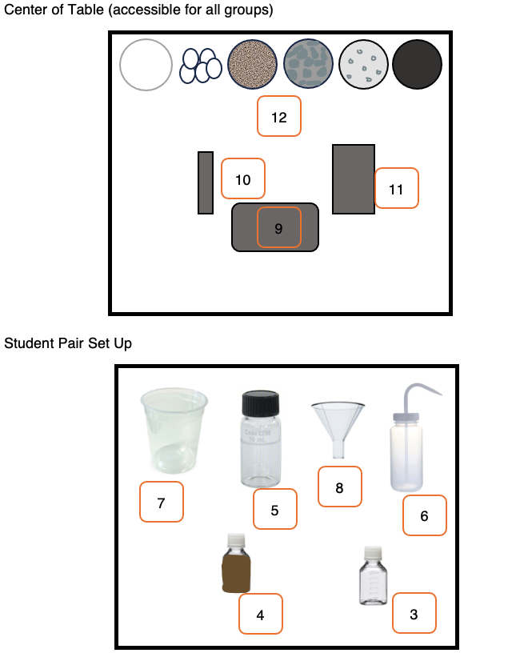

Materials
- Paper towel
- Pencils
- Empty 60mL bottle
- 60mL bottle with untreated water
- Turbidity bottle with cap
- Squeeze bottle with distilled water for rinsing
- Waste container
- Funnel
- Labquest (1 per table)
- pH sensor (1 per table)
- Turbidity sensor (1 per table)
- Filter Supplies (at each table, enough for 3 groups to share)
  - Coffee filters
  - Cotton balls
  - Sand
  - Pebbles
  - Calcite
  - Activated charcoal powder

REAGENT PREP

Dirty Water

Prepare as needed:
- To a 1 gallon container combine
  - 2 cups vinegar
  - Several drops of yellow food coloring
  - Dust/dirt from swept floor
  - ½ cup sand/soil
  - Pet or human hair, if available
  - Water up to 1 gallon

Aliquot into 60mL bottles for each student group.

EQUIPMENT PREP

LabQuest

Charge the LabQuest to full battery prior to activity.

Plug in the two sensors (pH and turbidity) to the LabQuest.

pH Sensor

Follow the provided Vernier instructions to calibrate the sensor.

Turbidity Sensor

Follow the provided Vernier instructions to calibrate the sensor.

LESSON PLAN

Introduction (5-10 min)
- Welcome students to the lab and direct them where to grab gloves and where to sit.
- Explain to students that they will be acting as environmental scientists looking to see if the nearby water sources are healthy.
- Ask students what makes water healthy?
  - Students might mention clarity, lack of toxin and pollutants,
- Ask students what might affect water health?
  - Students might mention changes in the environment, runoff from roads, pollutants from manufacturing or even spills.
- Explain to students that water’s health is often referred to as water quality. There can be many healthy waters with different water quality. Healthy helps us to draw a threshold for what is allowable and quality gives us ways to compare different healthy or unhealthy waters.
- Explain to students that their goal today will be to improve the water quality from our sample. Show the remaining dirty water sample and have them refer to their 60mL bottle.
- Ask students what looks concerning about this water sample.
  - Students might mention the color, the particulates (dirt, hairs, etc)
- Explain to students that we will investigate filters to see if we can remove these gross contaminants and let the pure water flow through.

Part 1: Initial Quality Testing (10-15 minutes)
- Explain to students that before we can filter our water, we need to get some baseline readings. We can refer back to these after filtration to see if these have changed or not.
- Explain that we will be using three water quality parameters to measure the water’s health: pH, turbidity, and dissolved oxygen.
- Ask students if they have heard of pH before? What is it?
  - pH is a measure of how acidic or basic a substance is. Substances with a pH below 7 are acidic (like lemon juice, vinegar, battery acid) and substances with a pH above 7 are basic (bleach, soap, milk).
  - Substances at pH 7 are considered neutral, neither acidic nor basic.
- Ask students what they think is a good pH for water?
  - 7 is ideal but the healthy range is anywhere from about 6-8.
- Ask students if they have heard of turbidity before? What is it?
  - It’s a measure of how clear a solution is. The more turbid a solution, the cloudier it will be.
- Ask students would we want water with a high or low turbidity?
  - Low. For drinking we want it as close to zero as possible but for aquatic life anything below 50 NTU is considered healthy.
- Direct students to the two probes connected to the Labquest at the center of their table. Explain that they will work with their partner to measure the quality of their water according to these parameters. Explain that students will share the probes with the other groups at their stations, but all sensors can be used simultaneously.
- Allow students to collect their data for the three parameters.
- Have groups report back on their data.
  - The water should be slightly acidic (due to the vinegar), should be slightly turbid (due to the dirt/dust/hair

Part 2: Filtration (10-15 minutes)
- Explain that now that we know the initial readings of our water, we will filter the water and measure these again.
- Explain that each group will design and test their own filter.
- Explain the materials that are available to go into the funnel.
- Ask students to make predictions on how each will perform.
- After hypotheses, direct students to start setting up their filter by placing the funnel on top of their empty bottle.
- Before students test their filter, remind them to prewet the filter by running distilled water through the filter into the waste container. Then the filter will be prepared for the untreated water.
- Have students slowly pour their water into the funnel, stopping as needed so the funnel doesn’t overfill.
- As the water filters through, direct students to make observations about the filtered water.
  - Did the color change? Are there any visible particles stuck in the filter itself?
- Direct students to show their bottle of filtered water to their table mates.
- By observation alone, ask students which filter seems to have worked the best to clean the water?
- Explain that to be sure that the water is safe, we’ll need to measure the pH and turbidity again.

Part 3: Final Quality Testing (10-15 minutes)
- Direct students to the two probes connected to the Labquest at the center of their table. Explain that they will work with their partner to measure the quality of their water according to these parameters. Explain that students will share the probes with the other groups at their stations, but all sensors can be used simultaneously.
- Allow students to collect their data for the two parameters.
- Have groups report back on their data focusing on drawing connections to the filter used.
- With this information, ask students to determine which filter was the best at improving the water’s quality?
- If time, explain that many filters have multiple layers to filter out different particulates and toxins and some filters have to be used multiple times to get the best result.
- Ask students to think of a new filter design. What materials should be included and how many times should the water go through the filter before being used?

Closing (5 minutes)
- Congratulate students on their successful first day as environmental scientists. Remind students that many companies in Maine need jobs like these to do their work.
- Explain more about 1-2 biotech companies in the area.

