What’s In a Change?

Topic(s): Chemistry
Grade level(s): 6th-8th grades
Time: One class period, 50-60 minutes
Maine Science and Engineering Standards: MS-PS1-2

ACTIVITY OVERVIEW
This activity dives into physical and chemical changes by having students learn and investigate the clues of each. Physical and chemical changes can be difficult concepts to teach students due to differences happening at the molecular level. This lab activity will allow students to see the differences between physical and chemical changes that challenge their observations and understandings. Students will look at amylose and water to see that creating a solution is not creating anything new chemically. They wil also look at calcium carbonate and acetic acid to see how the carbon dioxide gas produced when combined has different properties than the reactants.

ALIGNMENT TO STANDARDS

MS-PS1-2. Analyze and interpret data on the properties of substances before and after the substances interact to determine if a chemical reaction has occurred.

LEARNING OUTCOMES
Students will know:
- The common examples of physical change: color, shape, change of state of matter, density.
- The common examples of chemical change: change in temperature, change in color, noticeable odor after reaction, formation of a solid, formation of a gas.
- Mixing acetic acid and calcium carbonate is a chemical change.
- Mixing water and dry ice results in a physical change.
Students will understand:
- Appearance or form of matter changes in a physical change, but not the kind of matter in a substance, e.g. ice to water.
- Kind of matter changes in a chemical change and at least one new product or substance with NEW properties is formed, e.g.. calcium carbonate and acetic create carbon dioxide.
- Matter of different types will have different physical and/or chemical properties.
- What they do in this lab are the same skills needed in STEM careers.
Students will be able to:
- Collect and analyze data about the physical and chemical properties of substances.
- Use data as evidence to construct an argument that a change is chemical.
- Identify the formation of a new substance by interpreting data on the properties of substances before and after a change.
- Distinguish between physical and chemical changes in matter.

CAREER CONNECTIONS

Chemical Technician

Chemical technicians use special instruments, equipment, and techniques in research labs to assist chemists and chemical engineers.

Work Environment: Chemical technicians can usually be found in laboratories or manufacturing facilities.

Duties: Professionals in these jobs have the following duties and more: monitor chemical processes, test quality of products, setup and maintain lab equipment, troubleshoot problems, prepare chemical solutions, run experiments, analyze and interpret data results, prepare reports, and give presentations.

Median Salary: $49,820 (US Bureau of Labor Statistics, 2020)

Source: https://www.bls.gov/ooh/life-physical-and-social-science/chemical-technicians.htm

Food Chemist

A food chemist researches foods and their ingredients for improvements. This research could range from examining the balance of ingredients in different foods to improve the taste, to testing the quality of foods to ensure safety for human consumption before production, and sales.

Work Environment: Many food chemists work in laboratories and offices. Many food chemists work for the United States Food and Drug Administration, a federal agency.

Duties: Professionals in these jobs have a number of duties, such as testing food or drink samples to ensure they follow federal guidelines, observing quality of processing of food, and analyzing ingredients to offer accurate nutritional information.

Median US Salary: $68,830 (US Bureau of Labor Statistics, 2020)

Source: https://www.bls.gov/ooh/life-physical-and-social-science/agricultural-and-food-scientists.htm

Geochemist

A geochemist specializes in research that improves the quality of essential things for natural life, such as oil, minerals, and water. Geochemists often explore the history of the earth and its changing conditions.

Work Environment: Many geochemists work mainly outdoors. They are typically employed by oil companies, universities, and research institutes.
Duties: Professionals in these jobs have a number of duties, such as collecting environmental samples for quality testing, analyzing data for quality improvement, and writing reports and presenting them to other scientists or elected officials in a community.

Median US Salary: $93,580 (US Bureau of Labor Statistics, 2020)

Source: https://www.bls.gov/ooh/life-physical-and-social-science/geoscientists.htm

Materials Scientist
A materials scientist examines natural and man-made substances to document their composition, properties, and how the quality can be the most efficient.

Work Environment: Many materials scientists work in manufacturing facilities and laboratories. Many of these professionals are employed by technology manufacturing facilities.

Duties: Professionals in these jobs have a number of duties, such as examining chemical properties of different materials, testing the quality of materials, and creating materials to improve a specific model.

Median Salary: $80,680 (US Bureau of Labor Statistics, 2020)

Source: https://www.bls.gov/ooh/life-physical-and-social-science/chemists-and-materials-scientists.htm

Chemical Engineer
Chemical engineers apply chemistry, biology, physics, and math to solve problems involving the use of chemicals. This includes areas like fuel (biodiesel), drugs (vaccines), and food (GMOs).

Work Environment: You can find chemical engineers working in the office or in laboratories. You may also find them directly at work sites like an industrial plant or refinery to monitor and ensure operations run smoothly.

Duties: Chemical engineers are involved in a wide range of duties. These include conducting research, designing and planning the layout of instruments and equipment, conducting tests and monitoring performance, developing processes for step-by-step use, and much more. They can be responsible for overseeing entire projects or very specific processes within a project.

Median Salary: $108,540 (US Bureau of Labor Statistics, 2020)

Source: https://www.bls.gov/ooh/architecture-and-engineering/chemical-engineers.htm

BACKGROUND INFORMATION
In this activity, students will investigate different combinations to determine if they are physical or chemical changes. Students will measure physical and chemical properties of reactants and products and analyze their data to form their conclusions.

Students should be introduced to chemical and physical changes prior to this experiment. Students should know that chemical changes produce new substances and that those new substances will have different properties from the reactants. Physical changes occur when substances are combined but do not chemically change, the reactants have the same properties as the products but might differ physically.

Physical changes would include a change in state of matter (solid, liquid, gas), a change in size or shape, or even a color change as is seen in some solutions. Each change might affect how we view the substance, but at the molecular level, the substance is exactly the same. Chemical changes would occur when a new substance with new properties is created. This can be evidenced by the formation of a gas or precipitant (insoluble product), color change, change in temperature, or formation of an odor.

In our experiment, we utilize limewater (saturated Ca(OH)₂) and iodine as a way to determine chemical properties of a substance. When limewater comes into contact with carbon dioxide an insoluble product, calcium carbonate (CaCO₃), is created and turns the clear solution cloudy white. When iodine comes in contact with a starch, it creates a purplish/black product (details in article below). We will be testing our reactants and products to see if they react with limewater or iodine in addition to looking at a change in physical properties.

Physical and chemical change
- https://chem.libretexts.org/Bookshelves/Physical_and_Theoretical_Chemistry_Textbook_Maps/Supplemental_Modules_(Physical_and_Theoretical_Chemistry)/Fundamentals/Chemical_Change_vs._Physical_Change

Video of the interaction of carbon dioxide and limewater
- https://www.youtube.com/watch?v=Vl9A8Iyc_LY

Science of baking soda and vinegar
- https://www.youtube.com/watch?v=HmzFG_xOeaQ

Why Does Iodine Turn Starch Blue?
- https://www.chemistryviews.org/details/education/10128441/Why_Does_Iodine_Turn_Starch_Blue/

PRE-LABORATORY ENGAGEMENT

Invisible Ink
Before the mobile lab visit, students can complete the Invisible Ink activity for an introduction to chemical changes. In this activity, students will make an invisible ink of baking soda and water. This invisible solution can be revealed with grape juice and creates a color change, an indication of a chemical change.

PRE-LABORATORY ENGAGEMENT

Separation by Distillation
After the mobile lab visit, students can complete the Separation by Distillation activity by Science Buddies. It is recommended to use a powdered drink mix in this activity to highlight that a solution is a physical change because the reactants are unchanged (the water can be removed and is the same chemically at the end as it is in the beginning).

REAGENT PREPARATIONS

Amylose
- Fill 50mL conicals with about 30mL of cornstarch.
- Keep for use with multiple classes and refill as necessary.
Iodine
- Fill 50mL conicals with povidone iodine.
- Keep for use with multiple classes and refill as necessary.
Solid Calcium Carbonate
- Place 1 small boiling chip on a weigh boat for each station.
Powdered Calcium Carbonate
- Fill 50mL conicals with about 30mL of calcium carbonate.
- Keep for use with multiple classes and refill as necessary.
Water
- Fill 50ml conicals with distilled water.
- Keep for use with multiple classes and refill as necessary.
Acetic Acid
- Fill 50mL conicals with vinegar.
- Keep for use with multiple classes and refill as necessary.
Limewater
- Fill 50mL conical with saturated limewater.
  - The bottle often comes with undissolved powder at the bottom. For this reason, do not shake or invert before aliquoting.
  - If possible, filter the limewater through multiple coffee filters before aliquoting.
- Keep for use with multiple classes and refill as necessary.

STUDENT STATION SETUP
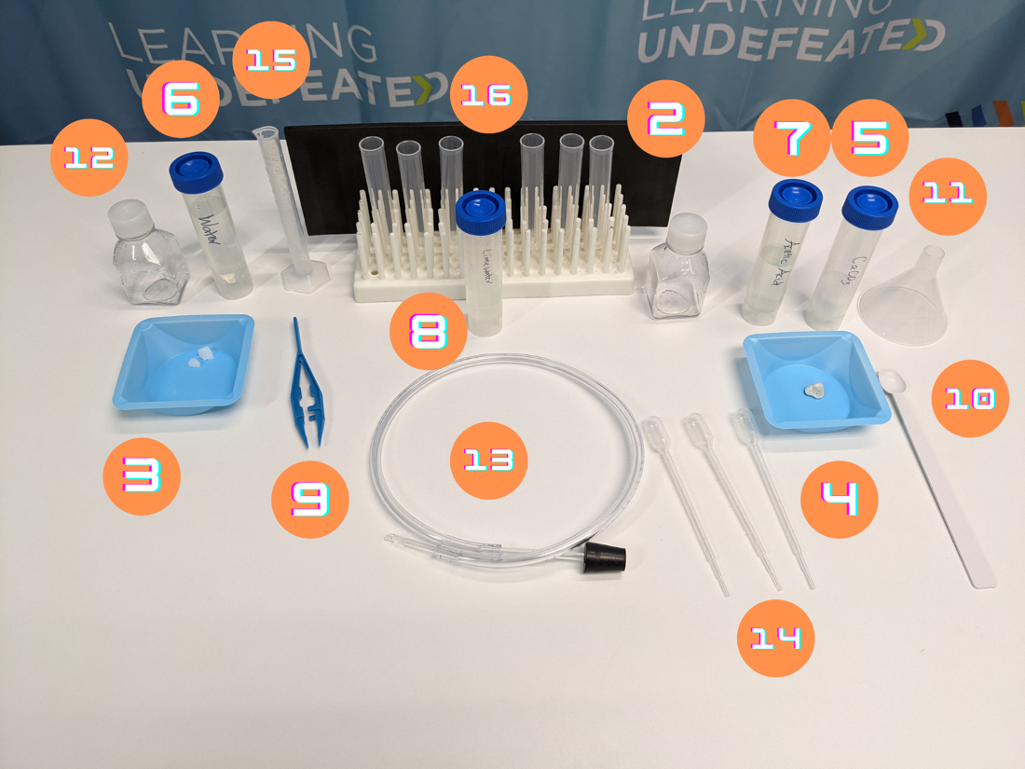

Each station accommodates 2 students who will work on the activity as a pair.
- Paper towel (optional)
- Peg rack
- 50mL concial of amylose
- Empty white weigh boat
- 50mL conical of iodine
- Weigh boat with at least 1 small piece of solid calcium carbonate
- 50mL conical of powdered calcium carbonate
- 50mL conical of water
- 50mL conical of acetic acid
- 50mL conical of limewater
- Forceps
- ¼ tsp measure
- Funnel
- 2 Small flasks or bottles
- Rubber stopper with vinyl tubing
- 3 transfer pipettes
- 10mL graduated cylinder
- 5 test tubes
- Permanent Marker

LESSON PLAN

Slide 1: Do Now: Think, Pair, Share
- As students enter, pass out the What’s in a Change? worksheet and have students read the activity introduction while the class settles in.
- After reading, instruct students to look at the question at the bottom of the first page. Have students “Think, Pair, and Share.” (Think about the question on their own, then discuss it with a partner, then finally discuss as a class.)
  - If a reactant has the same properties as the product of an interaction, did a physical or chemical change occur? Why?
    - If the reactants and products have the same properties, the change was most likely a physical change. Physical changes do not require a change in composition so the starting and ending materials would have the same molecules with the same properties.

Slide 2: What’s in a Change?
- Introduce today’s activity about types of changes and ensure students are aware that it is a laboratory activity.

Slide 3: Learning Objectives
- Explain to students that at the end of today’s activity, they will have done the following:
  - Observed and recorded chemical and physical properties of substances.
  - Identified evidence of chemical and physical changes.
  - Analyzed data to form conclusions about the type of change demonstrated.

Slide 4: What Do You observe?
- Have students view the two GIFs on the slide and ask them if either shows a change. Ask them how they know a change occurs.
  - For the can crushing, students might observe that it changed in size and shape. For the elephant toothpaste, students might observe that something very large was created from something small or that liquids seem to change into something more solid.
- Explain that both are changes, but of different types. The can being crushed is an example of a physical change and the reaction on the right is an example of a chemical change.

Slide 5: Physical Changes
- Explain to students that a physical change may change the way a substance looks, but the molecules that make it up remain unchanged.
- Ask students if they know of any ways to physically change a substance like paper.
  - Answers include crumpling it, cutting/ripping it into pieces, or drawing on the paper with pencils or markers.
  - Teacher’s Note: Emphasize with each correct example that after the action, the paper remains the same at the molecular level.
- Ask students if they know of any ways to physically change a substance like water.
  - Answers include pouring it into separate glasses, adding dyes, or heating it.
  - Teacher’s Note: Emphasize in the case of heating or cooling, the water remains the same even as its phase changes.
Slide 6: Phase Changes (Optional)
- Explain to students that a phase change does not change the substance, but it does impact the way the substance behaves.
- Explain that there are three main phases: gas, liquid, and solid. They each have different properties.
- Explain to students that we can change from one phase to another when heat or pressure is added or removed. Advance the slide to show a short video of phases.

Slide 7: Chemical Change
- Explain to students that a chemical change allows molecules to rearrange to create new substances. We can identify chemical changes have occurred if the products have different properties from the reactants.
- Ask students to think of cookie dough compared to fully cooked cookies. Ask students what changes we observe in this task.
  - A new smell after baking and a darker golden color.
  - Teacher’s Note: Emphasize that these are two pieces of evidence (new odor/ color change) that can help us identify chemical changes.
- Advance the slide to show examples of clues of a chemical change. Explain to students that chemical reactions can be clued in by color changes, new odors, a change in temperature, a formation of light, production of a gas, or production of a precipitate (an insoluble product).
  - Teacher’s Note: Emphasize that though these clues can indicate a chemical reaction, we must analyze the reactants’ and products’ properties to provide strong evidence that a chemical change occurred.

Slide 8: Properties
- Explain to students that every substance has physical and chemical properties.
- Explain to students that physical properties can be observed or measured without changing the substance in the process. Ask students if they can think of any examples of physical properties.
  - Most common examples: color, size, shape, mass, and hardness.
  - Other examples students might not think of include density, boiling point, melting point, odor, and solubility.
  - Teacher’s Note: Advance the slide for these properties to appear listed on the slide.
- Explain to students that chemical properties only become evident during or after a chemical reaction. The only way to establish the property is by changing the substance’s chemical identity. Ask students if they can think of any examples of chemical properties.
  - Students might have a hard time thinking of examples of these, but some simple ones include flammability (how easily something will burn or ignite) and heat of combustion (how much heat energy is released when a substance is burned with oxygen).
  - Teacher’s Note: Advance the slide for these properties to appear listed on the slide.

Slide 9: Reactions with Limewater – Carbon Dioxide
- Explain to students that in today’s lab they will be observing the chemical reaction with limewater as a property of the substance they work with. Elaborate to say that limewater reacts with carbon dioxide to turn a clear solution milky white. A demonstration can be conducted by exhaling into a test tube of limewater to help students understand this chemical property.

Slide 10: Reactions with Iodine - Starch
- Explain that we will also be using the interaction with iodine to identify the presence of starches. When they are together, the complex creates a dark black/blue/purple color.
- Explain that we’ll use our knowledge of the products to determine if we should test for starch or carbon dioxide.

Slide 11: Today’s Investigation
- Introduce students to the two combinations they will be investigating in their activity.
- Show students the amylose and water separately before combining them in a beaker or flask. Ask students what they observe happening.
  - A white liquid is formed
- Ask students what they think the liquid is and if they think it is evidence of a chemical or physical change.
  - Teacher’s Note: Do not confirm or deny their hypothesis. Allow students to use the activity to confirm or reject their hypothesis.
- Ask students if we should test this interaction for carbon dioxide or starch.
  - Starch
    - Teacher’s Note: Remind students that carbon dioxide is usually a gas at room temperature. When a gas is produced we’ll normally see bubbles. If no bubbles are seen in the bottle, there likely isn’t a gas being produced.
- Show students the acetic acid and powdered calcium carbonate separately before combining them in a beaker or flask. Ask students what they observe happening.
  - Bubbles formed.
- Ask students what they think the bubbles are and if they think it is evidence of a chemical or physical change.
  - Teacher’s Note: Do not confirm or deny their hypothesis. Allow students to use the activity to confirm or reject their hypothesis.
- Review lab safety protocols with students prior to beginning the activity.
- Break students into groups of two to three and assign each group a station in the laboratory/classroom.
  - Teacher’s Note: Students will work on their worksheets, but have their responses recorded collectively through the slides.

Slide 12: Part 1 Observing Physical and Chemical Properties of Reactants
- Review the procedure for Part 1 “Observing Physical and Chemical Properties of Reactants.” Emphasize the importance of taking observations before and after to identify if a new substance is created.
- Review and record collected data in the table on the slide.
Slide 13: Part 1 Observing Physical and Chemical Properties of Products
- Review the procedure for Part 1 “Observing Physical and Chemical Properties of Products.”
- Review and record collected data in the table on the slide.
- If time allows, review the “Quick Check” questions with students. This can also be a student’s exit ticket or homework.
  - Does the product have similar chemical properties to either of the reactants?
    - Yes, the product formed a black color as did the amylose reactant.
  - Can you still see the amylose when it was added to the water? When combined what did it make?
    - Yes, it’s floating in the water. It made a solution or mixture.

Slide 14: Part 2 Observing Physical and Chemical Properties of Reactants
- Review the procedure for Part 2 “Observing Physical and Chemical Properties of Reactants.” Emphasize the importance of taking observations before and after to identify if a new substance is created.
  - Students will observe and test calcium carbonate rock for this part of the procedure, NOT powdered calcium carbonate.
- Review and record collected data in the table on the slide.

Slide 15: Part 2 Observing Physical and Chemical Properties of Products
- Review the procedure for Part 2 “Observing Physical and Chemical Properties of Products.” Point out that students will be using powdered calcium carbonate for this part of the procedure to get the fastest reaction possible.
  - Teachers Note: The calcium carbonate rock does react with acetic acid but on a much longer time scale (30-60 min). Therefore we switch to powdered calcium carbonate for the product testing. Powdered calcium carbonate takes a while to settle in limewater and can lead to misconceptions that it creates a precipitate.
- Review and record collected data in the table on the slide.
- If time allows, review the “Quick Check” questions with students. This can also be a student’s exit ticket or homework.
  - Compare the unknown product to the reactants. Does the unknown product have different properties than the reactants? What type of change occurred: chemical or physical? Why?
    - Yes, the unknown product does have different properties than the reactants. It reacts with limewater while the other reactants did not and is a gas while the reactants were solid and liquid. This means that a chemical change occurred because a new substance with different properties was created.

Slide 16: Clean up
- Review lab clean up with students so they can dispose of supplies and neaten their station before leaving.

